
Company
Logotype

Cone Beam Computed Tomography- Report



Porur Dental X-rays & CBCT

Patient Name : Mrs. Kamarnisha | Date of Report : 08.05.2024
Age/ Gender : 59 years/ Female | Region of Interest : CBCT Full Skull
Referring doctor: Dr. Joshua | Indication : Implant assessment
Clinical Notes: Nil
PATIENT INFORMATION

CBCT- Full Skull provided
CBCT – IMAGE DETAILS

RADIOGRAPHIC INTERPRETATION

- Complete loss of crown and root structure in relation to 16, 17, 18, 23, 24, 25, 26, 27, 28, 31, 32, 38, 41, 42, 43, 45, 46.
- The alveolar ridge in relation to the maxillary and mandibular alveolar ridge is present with normal trabecular pattern.
- Presence of generalized bone loss extending beyond the middle third of roots in the mandibular arch.
- In relation to the left maxillary sinus, presence of mucosal thickening in relation to the floor of the sinus is evident.

IMPLANT ASSESSMENT

 | 11 region | 12 region | 13 region | 14 region | 21 region | 22 region | 23 region | 24 region
Sub-Crestal | 6.6 | 5.5 | 7.1 | 8.1 | 6.8 | 5.3 | 3.3 | 4.2
Mid- Crestal | 6.9 | 5.8 | 7.4 | 8.3 | 7.2 | 5.1 | 4.2 | 4.4
Distance between the alveolar ridge and Floor of the Nasal cavity (in mm) | 15 | 12.2 | 10.6 | 9.9 | 14.5 | 15.7 | 14.3 | 12.7

 | 15 region | 16 region | 17 region | 25 region | 26 region | 27 region
Sub-Crestal (in mm) | 6.5 | 5.5 | 5.1 | 3.6 | - | -
Mid- Crestal (in mm) | 7.6 | - | - | 3.7 | - | -
Distance between the alveolar ridge and floor of the maxillary sinus (in mm) | 6.2 | 3.8 | 2.6 | 10.6 | 1.3 | 1

 | 31 region | 32 region | 33 region | 34 region
Sub-Crestal (in mm) | 3 | 4.7 | 6.3 | 6.2
Mid- Crestal (in mm) | 4.4 | 6.1 | 6.8 | 6.8
Distance between alveolar ridge and the inferior border of mandible (in mm) | 18.1 | 17.7 | 20.6 | 21.9

 | 41 region | 42 region | 43 region | 44 region
Sub-Crestal (in mm) | 2.7 | 3 | 4.3 | 7.5
Mid- Crestal (in mm) | 3.1 | 4.1 | 4.8 | 7.5
Distance between alveolar ridge and the inferior border of mandible (in mm) | 15.2 | 14.9 | 17.9 | 17.6
 | 45 region | 46 region | 47 region
Sub-Crestal (in mm) | 5.8 | 5.8 | 8.9
Mid- Crestal (in mm) | 7.8 | 7.7 | 9.2
Distance between alveolar ridge and the inferior alveolar nerve canal (in mm) | 8.6 | 11 | 8.4
Distance between alveolar ridge and the inferior border of mandible (in mm) | 19 | 21.7 | 19.6

 | 35 region | 36 region | 37 region
Sub-Crestal (in mm) | 6.9 | 8.7 | 6.4
Mid- Crestal (in mm) | 8.1 | 10.1 | 7.1
Distance between alveolar ridge and the inferior alveolar nerve canal (in mm) | 12.4 | 11.1 | 8.8
Distance between alveolar ridge and the inferior border of mandible (in mm) | 25.6 | 23.9 | 21

RADIOGRAPHIC IMPRESSION

- Partially edentulous maxillary and mandibular arch.
- Generalized Chronic Periodontitis.
- Left maxillary sinusitis.

Kindly correlate with clinical findings


IMAGES FOR REFERENCE

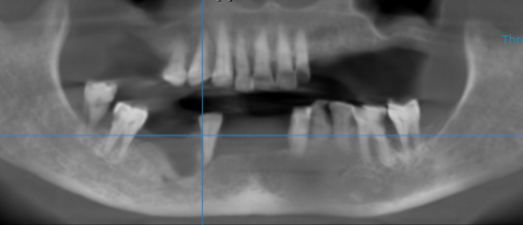
RECONSTRUCTED PANORAMIC VIEW

3-DIMENSIONAL VIEW

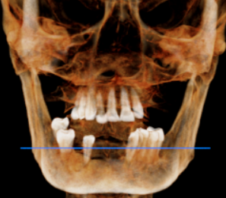

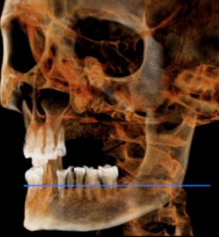
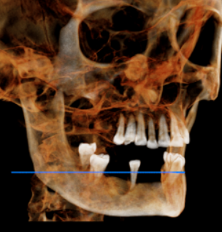

CROSS SECTIONAL VIEW

11 region | 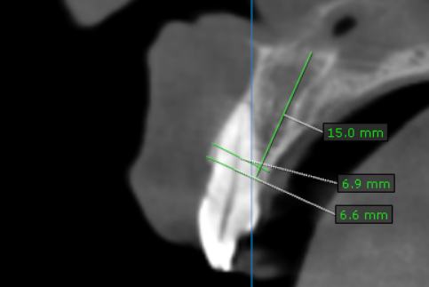
12 region | 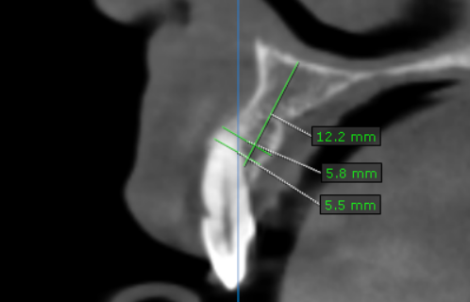
13 region | 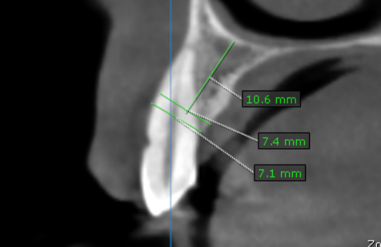
14 region | 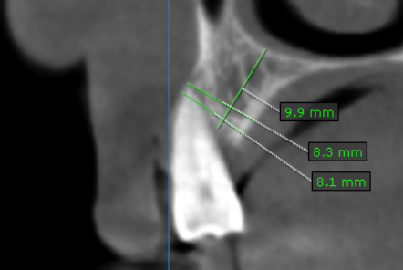
15 region | 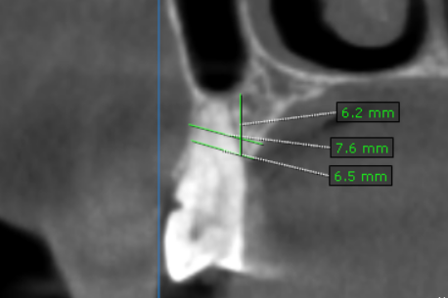
16 region | 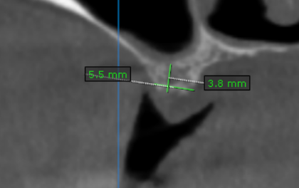
17 region | 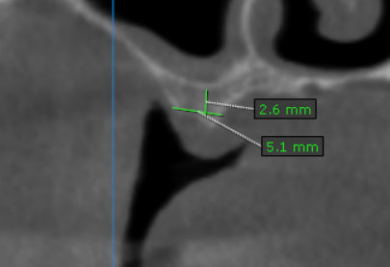
21 region | 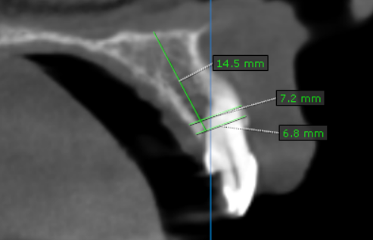
22 region | 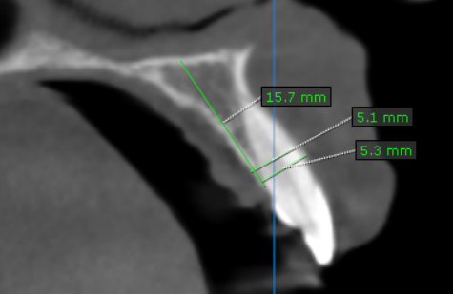
23 region | 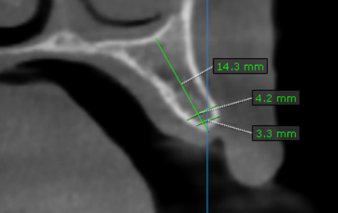
24 region | 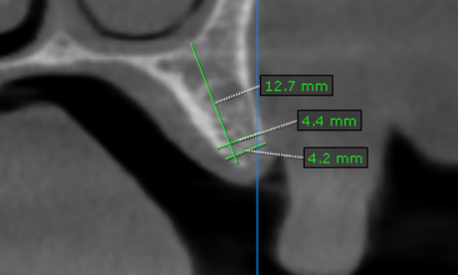
25 region | 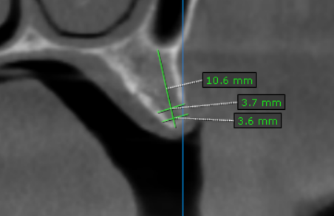
26 region | 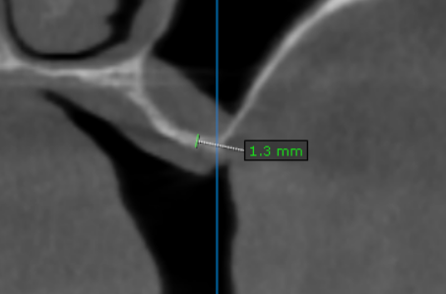
27 region | 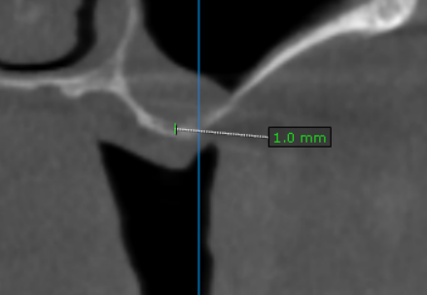
31 region | 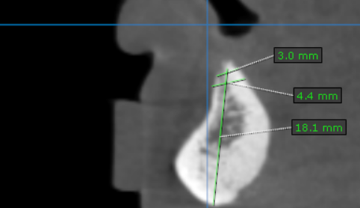
32 region | 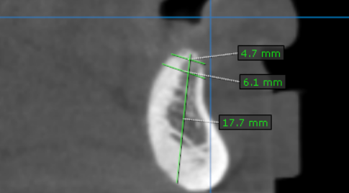
33 region | 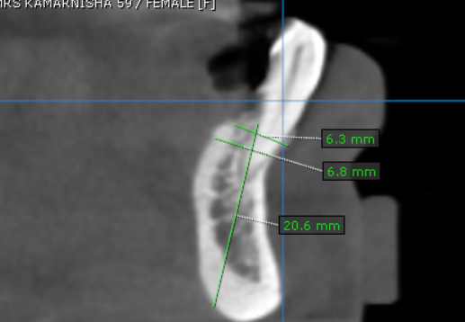
34 region | 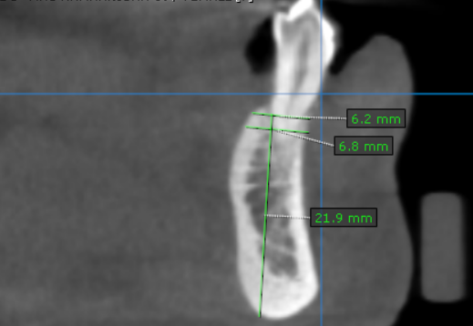
35 region | 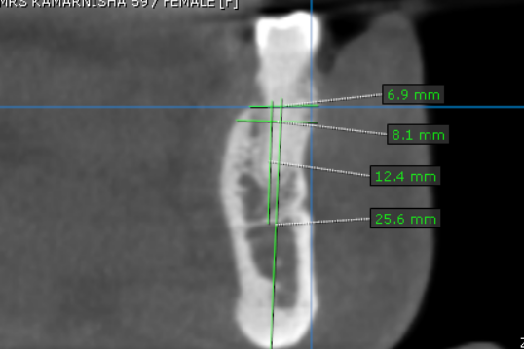
36 region | 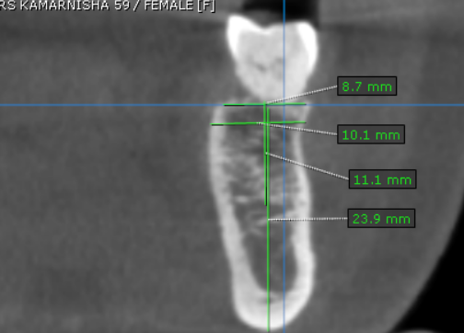
37 region | 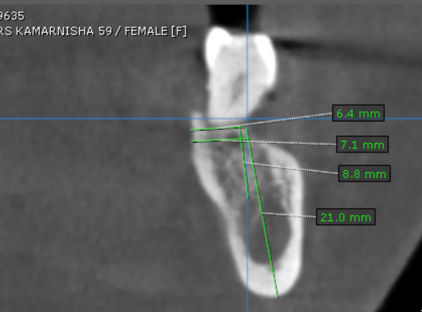
41 region | 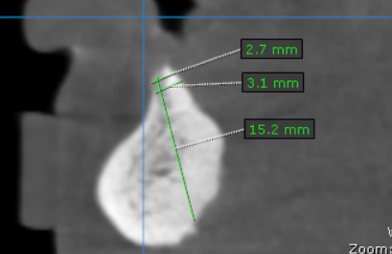
42 region | 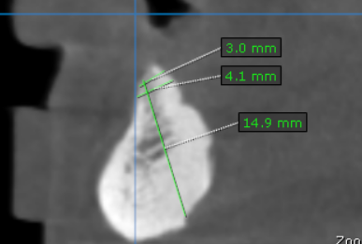
43 region | 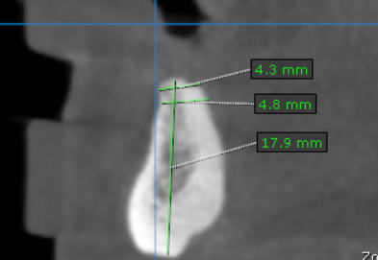
44 region | 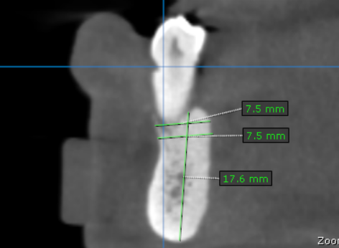
45 region | 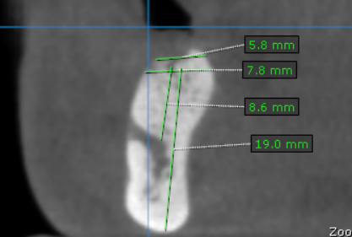
46 region | 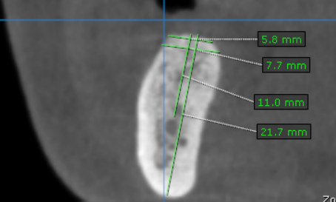
47 region | 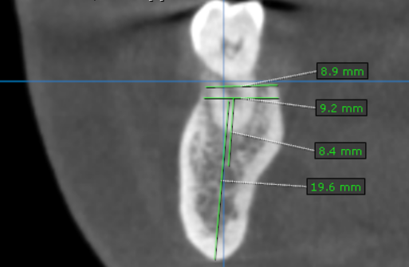

**** End of report ****

